Gift certificate

Gift Certificates set up:

**Administration > Financial Settings > Gift Certificate Types > Add New**

In this box you will have the option to choose a Default Amount for your gift certificate but also the ability to allow the amount to be changed.

You will need a GL account that is set up as a liability account to attach to the Gift Certificate. If you already have a liability Gift Certificate Account set up, you can use it. If you don't, then set it up under: **Administration > Financial Settings > GL accounts > Add New** and create your Liability account before you set up the Gift Certificate.

If you have an expiry date for when customers can use their gift certificate until or a time period after date of purchase, you can also set that up. Once you have created a Gift Certificate, you will see the option "sell gift certificate" at the front desk main screen. Gift certificates are attached to the customer who it is sold to, similar to credit on account. A different payer can pay but you will have to set up a customer account for the person receiving the gift certificate or sell it under the 'drop-in customer' and print out a gift card receipt.

For online sales you will need to activate the functionality under**: Administration > System settings > Configuration – Internet staff**. When the function is turned on for online side, it should validate the value of 'Gift Certificate Numbering' on **'Administration » Financial Settings » Configuration**'(see below). If it is 'use custom gift certificate numbers', the action will be blocked, and an error message would be shown: It is not allowed to use custom gift certificate number for online sale. Please go to **'Administration » Financial Settings » Configuration**' to turn on system generated gift certificate numbers first.

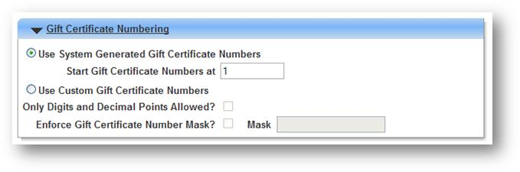

Note: if the online sale is turned on, while users change the gift certificate numbering option afterward to be custom numbers, the change would be blocked and warning messages would be shown: It is not allowed to use custom gift certificate number for online sale.

Similar to other available actions in public side, the ability for public users to view their purchased gift certificate would be controlled on staff side. Once the option is turned on, public users can view their and their family's purchased gift certificate online.

**Administration » System Settings » Configuration – Online**

